IMPORTANT CUSTOMER CHURN SQL ANALYSIS

PROJECT TITLE: CUSTOMER CHURN ANALYSIS

DATASET INFORMATION:
- ROWS – 64374
- COLUMNS- 12

OBJECTIVE: Analyse customer churn patterns using SQL Queries

DETAILED ANALYSIS:

1) Total No of Customers

QUERY:
SELECT COUNT(*) AS Total_Customers
FROM customer_churn;

OUTPUT:
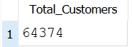

2) Churn Rate (%)

QUERY:
SELECT ROUND(COUNT(CASE WHEN Churn=1 THEN 1
END)*100/COUNT(*),2) AS Churn_Rate
FROM customer_churn
OUTPUT:

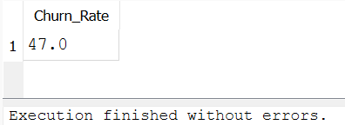

3) Active vs Churned Customers

QUERY:
SELECT Churn,COUNT(*) AS Customers
FROM customer_churn
GROUP BY Churn;

OUTPUT:
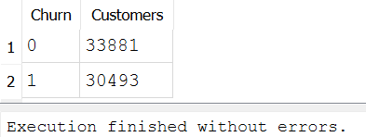

4) Gender wise Churn Analysis

QUERY:
SELECT Gender,Churn,COUNT(*) AS Customers
FROM customer_churn
GROUP BY Gender,Churn
ORDER BY Gender;

OUTPUT:

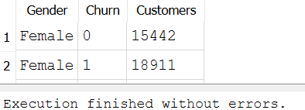

5)Subscription Type Analysis

QUERY:
SELECT
"Subscription Type",
COUNT(*) AS Total_Customers,
ROUND(AVG("Total Spend"),2)AS Avg_Spend
FROM customer_churn
GROUP BY "Subscription Type"
ORDER BY Total_Customers DESC;

OUTPUT:

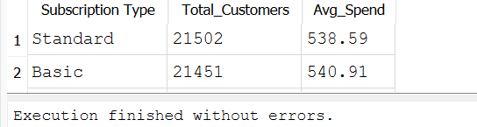

6) Contract Length vs Churn

QUERY:
SELECT
"Contract Length",
COUNT(*) AS Customers,
SUM(Churn) AS Churned_Customers
FROM customer_churn
GROUP BY "Contract Length";

OUTPUT:

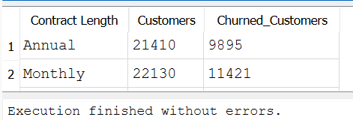

7) Average Spending by Subscription Type

QUERY:
SELECT
"Subscription Type",
ROUND(AVG("Total Spend"),2) AS Average_Spend
FROM customer_churn
GROUP BY "Subscription Type"
ORDER BY Average_Spend DESC;

OUTPUT:

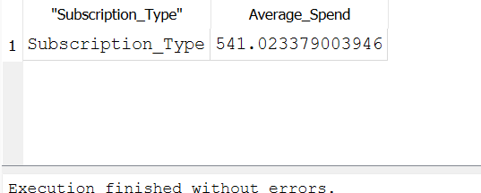

8) Top 10 Highest Spending Customers

QUERY:
SELECT CustomerID, Age, Gender,"Total Spend"
FROM customer_churn
ORDER BY "Total Spend" DESC
LIMIT 10;

OUTPUT:

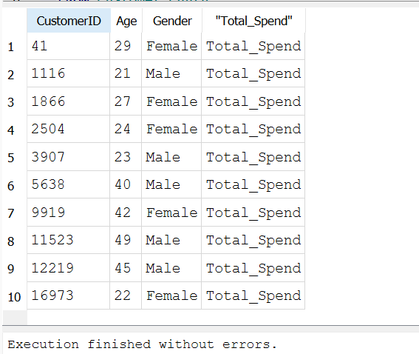

9) Average Tenure by Churn Status

QUERY:
SELECT Churn,
ROUND(AVG(Tenure),2)AS Average_Tenure
FROM customer_churn
GROUP BY Churn;

OUTPUT:

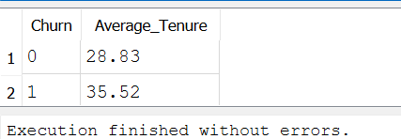

10) Support Calls vs Churn

QUERY:
SELECT
"Support Calls",
COUNT(*) AS Customers,
SUM(Churn) AS Churned_Customers
FROM customer_churn
GROUP BY "Support Calls"
ORDER BY "Support Calls";

OUTPUT:

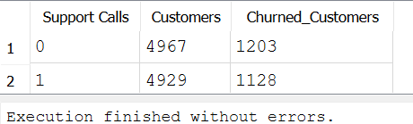

11) Pyment Delay Analysis

QUERY:
SELECT
"Payment Delay",
COUNT(*) AS Customers
FROM customer_churn
GROUP BY "Payment Delay"
ORDER BY "Payment Delay" DESC;

OUTPUT:

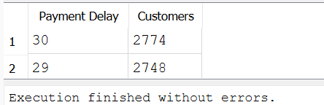

12) TOP 5 Ages with Highest Churn

QUERY:
SELECT
Age,
COUNT(*) AS Churned_Customers
FROM customer_churn
WHERE Churn=1
GROUP BY Age
ORDER BY Churned_Customers DESC
LIMIT 5;

OUTPUT:

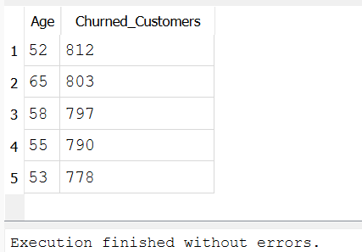

INSIGHTS AND RECOMMENDATION:

1. Total Customers
Insight:
The dataset contains 64,374 customers, providing a comprehensive sample for customer churn analysis and ensuring reliable business insights.
Recommendation:
Continue expanding the customer base while strengthening retention initiatives to maximize long-term customer value.

2. Churn Rate (47%)
Insight:
The overall churn rate is 47%, indicating that nearly one out of every two customers has left the service. This represents a significant customer retention challenge.
Recommendation:
Implement targeted retention campaigns, loyalty programs, and personalized customer engagement strategies to reduce churn.

3. Active vs Churned Customers
Insight:
- Active Customers: 33,881
- Churned Customers: 30,493
Although the company retains more customers than it loses, the difference is relatively small, indicating considerable room for improving retention.
Recommendation:
Analyze the characteristics of churned customers and proactively engage customers who show similar behavioral patterns.

4. Gender-wise Churn Analysis
Insight:
Among female customers:
- 15,442 customers were retained.
- 18,911 customers churned.
The visible results indicate that female customers experienced higher churn than retention.
Recommendation:
Conduct further analysis on female customer preferences and introduce personalized offers, loyalty rewards, and targeted engagement campaigns.
5. Subscription Type Analysis
Insight:
- Standard subscription has the highest customer base (21,502).
- Basic subscription has 21,451 customers.
- However, the Basic plan records a higher average spend (540.91) than the Standard plan (538.59).
Recommendation:
Maintain the popularity of the Standard plan while encouraging Basic customers to upgrade through value-added features and promotional offers.

6. Contract Length vs Churn
Insight:
- Monthly Contracts: 22,130 customers, 11,421 churned
- Annual Contracts: 21,410 customers, 9,895 churned
Monthly contracts show both a larger customer base and a higher number of churned customers than annual contracts.
Recommendation:
Encourage customers to choose annual contracts by offering discounts, exclusive benefits, or loyalty rewards to improve retention.

7. Average Spending by Subscription Type
Insight:
The average spending displayed is 541.02. However, because the query grouped by "Subscription_Type" instead of "Subscription Type", the output shows only one aggregated row instead of separate subscription categories.
Recommendation:
Correct the SQL query using the proper column name ("Subscription Type") to compare average spending across different subscription plans accurately.

8. Top 10 Highest Spending Customers
Insight:
The report identifies the Top 10 highest-spending customers, including Customer IDs 41, 1116, 1866, 2504, 3907, and others. However, the spending values are not displayed because the query selected "Total_Spend" instead of "Total Spend".
Recommendation:
Correct the query and establish a VIP customer program offering personalized services, premium support, and exclusive rewards to retain high-value customers.

9. Average Tenure by Churn Status
Insight:
- Retained Customers: Average tenure 28 months
- Churned Customers: Average tenure 35 months
Interestingly, churned customers have a longer average tenure than retained customers, suggesting that even long-term customers are leaving.
Recommendation:
Regularly engage long-term customers through loyalty programs, exclusive benefits, and personalized communication to prevent attrition.
10. Support Calls vs Churn
Insight:
- 0 Support Calls: 4,967 customers, 1,203 churned
- 1 Support Call: 4,929 customers, 1,128 churned
Even customers with few support calls experienced churn, indicating that factors beyond customer support may also influence customer attrition.
Recommendation:
Continue improving service quality while analyzing additional factors such as pricing, contract type, and payment behavior to identify the primary drivers of churn.
11. Payment Delay Analysis
Insight:
- 30-day payment delay: 2,774 customers
- 29-day payment delay: 2,748 customers
Longer payment delays are common among a significant number of customers and may indicate potential financial stress or reduced engagement.
Recommendation:
Introduce automated payment reminders, flexible payment plans, and proactive follow-up communications to reduce payment delays and improve customer retention.
12. Top 5 Ages with Highest Churn
Insight:
The age groups with the highest churn are:
- 52 years: 812 customers
- 65 years: 803 customers
Customers aged 52 years recorded the highest churn, followed closely by customers aged 65 and 58.
Recommendation:
Develop targeted retention campaigns, personalized offers, and customer engagement strategies specifically for customers in the 52–65 age group, as they represent the highest churn segment.

THANK YOU

